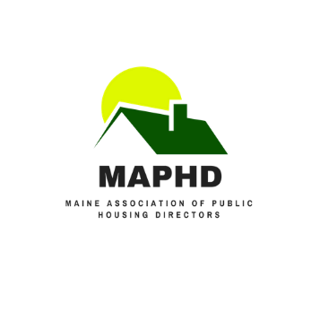

MAPHD Rent Calculation Training

Lodging Options in Bar Harbor

Training to take place at the YWCA in Bar Harbor, Maine May 23rd - May 25th

There are more than enough lodging options in Bar Harbor! Here are a few that are in walking distance to where the training will be held:

- Primrose Inn/ Place
73 Mount Desert Street - 288 4031 - relax@primroseinn.com
Rates $99-$109 - Place
Rates $155 - $239 - Inn

- Quality Inn
40 Kebo Street - 288 5403 - reservations@barharborqualityinn.com
Rates $119

- Acadia Hotel
20 Mount Desert Street - 288 5721 - acadiahotel@gmail.com
Rates $139 - $309

- Moseley Cottage Inn & Town Motel
12 Atlantic Ave - 288 5548 - stay@moseleycottage.net
Rates $ $99 - $205

